Using Scraping&Crawling
with Feedly&Python:



Introduction:
I have been learning about web scraping and crawling, and I find these techniques really useful for getting data from websites and organizing it. Using Python, I can do this easily with libraries like `requests` and `BeautifulSoup`. When I combine these tools with Feedly, I can monitor and scrape content from RSS feeds and websites. In this report, I’ll explain how I do web scraping and crawling with Feedly and Python, and I’ll show some examples of the code I used to extract data from a webpage.

Scraping and Crawling?
1- Crawling: This is when I navigate through a website to find URLs and metadata. It’s like exploring the structure of the site.
2- Scraping: This is when I extract specific data from a webpage, like titles, articles, or images.

When I do web scraping, I use Python’s `requests` library to send HTTP requests and `BeautifulSoup` to parse and extract the HTML elements from the website.

Using Feedly:
I use Feedly to gather and follow updates from websites that I’m interested in. Feedly makes it easier for me to find new content to scrape because it organizes RSS feeds from different websites. This saves me time since I don’t have to search for content manually. 

My Feedly Sources:
For my project, I chose the website "[Video Games Chronicle](https://www.videogameschronicle.com)" because it has cool articles about video games. I use Feedly to keep track of their latest articles, like one about *Virtua Fighter 5*, which I decided to scrape.

Code Example 1: How I Scraped with `BeautifulSoup`
What I Did: I extracted all the links, the title of the article, its content, and the images from the webpage.
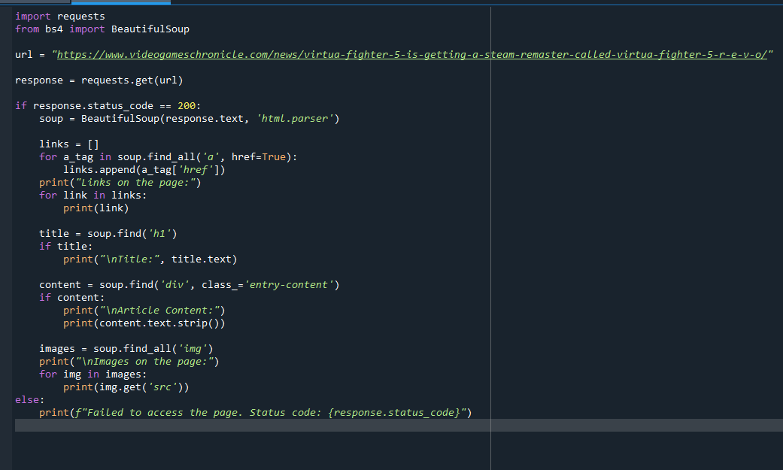
My Code ”1”:
import requests
from bs4 import BeautifulSoup

url = "https://www.videogameschronicle.com/news/virtua-fighter-5-is-getting-a-steam-remaster-called-virtua-fighter-5-r-e-v-o/"

response = requests.get(url)

if response.status_code == 200:
soup = BeautifulSoup(response.text, 'html.parser')

links = []
for a_tag in soup.find_all('a', href=True):
links.append(a_tag['href'])
print("Links on the page:")
for link in links:
print(link)

title = soup.find('h1')
if title:
print("\nTitle:", title.text)

content = soup.find('div', class_='entry-content')
if content:
print("\nArticle Content:")
print(content.text.strip())

images = soup.find_all('img')
print("\nImages on the page:")
for img in images:
print(img.get('src'))
else:
print(f"Failed to access the page. Status code: {response.status_code}")
What Happened:
When I ran this code:
1. Crawling: It collected all the hyperlinks from the `<a>` tags.
2. Scraping: It grabbed the title of the article from the `<h1>` tag.
3. It got the article content by looking for a specific class name.
4. Scraping: It found all the image links.

Example Output:
- Links: I found a lot of links, including navigation links and social media links.
- Title: Virtua Fighter 5 is getting a Steam remaster called Virtua
Fighter 5 R.E.V.O.
- Content: I scraped the whole news article.
- Images: I got the URLs for all the images on the page.
Part of the code display :
Links on the page:
https://www.videogameschronicle.com/
#main-men
/category/news/
/category/review/
/category/features/
https://www.videogameschronicle.com/platforms/playstation/
Title: Virtua Fighter 5 is getting a Steam remaster called Virtua Fighter 5 R.E.V.O.

Images on the page:
/files/2024/11/virtua-fighter-5-revo-320x180.jpg
/files/2024/11/virtua-fighter-5-revo-pic2-80x45.jpg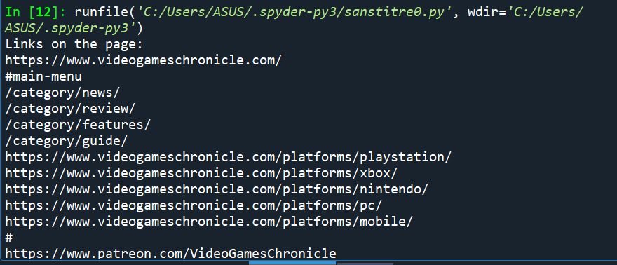

Code Example 2: How I Searched and Saved Data to CSV
What I Did: I searched for a specific keyword in the webpage’s content and saved the results in a CSV file.
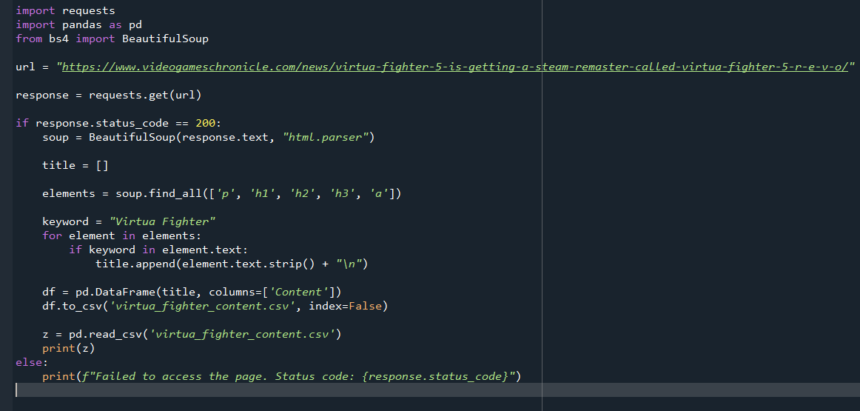

My Code”2”:
import requests
import pandas as pd
from bs4 import BeautifulSoup

url = "https://www.videogameschronicle.com/news/virtua-fighter-5-is-getting-a-steam-remaster-called-virtua-fighter-5-r-e-v-o/"

response = requests.get(url)

if response.status_code == 200:
soup = BeautifulSoup(response.text, "html.parser")

title = []

elements = soup.find_all(['p', 'h1', 'h2', 'h3', 'a'])

keyword = "Virtua Fighter"
for element in elements:
if keyword in element.text:
title.append(element.text.strip() + "\n")

df = pd.DataFrame(title, columns=['Content'])
df.to_csv('virtua_fighter_content.csv', index=False)

z = pd.read_csv('virtua_fighter_content.csv')
print(z)
else:
print(f"Failed to access the page. Status code: {response.status_code}")
What Happened:
This code found all the parts of the page with the keyword "Virtua Fighter" and saved them in a CSV file. I then opened the file to see the results.
- Saved CSV: The content was saved in `virtua_fighter_content.csv`.
- Content: I got paragraphs, headings, and links that mentioned "Virtua Fighter."

Example Output:
Content
*Virtua Fighter 5 is getting a Steam remaster...
*Sega has announced that a remaster of Virtua
|*Battle through classic VF modes like Arcade.. |
Part of the code display :

runfile('C:/Users/ASUS/.spyder-py3/sanstitre0.py', wdir='C:/Users/ASUS/.spyder-py3')
Content
0 Virtua Fighter 5 is getting a Steam remaster c...
1 Sega has announced that a remaster of Virtua F...
2 The remaster will be called Virtua Fighter 5 R...
3 “The legendary fighting series makes its Steam...
4 “Battle through classic VF modes like Arcade o...
5 Sega’s head of transmedia seemingly let slip t...
6 In an interview about a range of topics, Justi...
7 “We have a suite of titles in development righ...
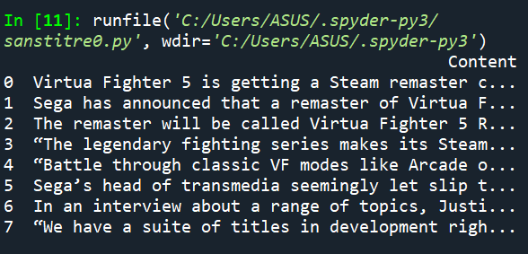

Comparing What I Did in Both Codes:
Feature | Code Example 1 | Code Example 2
Purpose | General scraping and crawling | Targeted scraping with filtering
Data Storage | Printed results to console | Saved results to CSV
Focus | Broad scraping of all page content | Keyword-specific scraping
Applications | Exploring the content | Focused data collection

Conclusion :
By doing these scraping and crawling exercises, I learned how to use Python to automate content collection and analysis. With Feedly, I can easily pick the sources I want to scrape. This makes my work faster and more organized. These techniques are great for:
- Collecting data for research or projects.
- Analyzing trends in website content.
- Automatically gathering specific information from webpages.

1. Feedly RSS Feed: [https://feedly.com](https://feedly.com)
2. Video Games Chronicle: [https://www.videogameschronicle.com](https://www.videogameschronicle.com)
3. Python Libraries:
- `requests`: [https://pypi.org/project/requests](https://pypi.org/project/requests)
- `BeautifulSoup`: [https://www.crummy.com/software/BeautifulSoup/](https://www.crummy.com/software/ BeautifulSoup/)
4. Pandas Documentation: [https://pandas.pydata.org](https://pandas.pydata.org)

